**Key Findings**

**Test Strategy**

For the following test strategy we have used the following:

* Target Concurrency: 50
* Ramp up Time: 50
* Ramp Up Steps Count: 10

Target Concurrency means the number of users which is set to 50, Ramp up times and steps count will work as follow:  
The ramp-up time is configured as 50, with 10 steps. Therefore, the calculation for the interval between steps is 50/10, resulting in 5 seconds. Consequently, every 5 seconds, we aim to achieve a target concurrency of 50/10, which equals 5 users. This means that every 5 seconds, we increment the user count by 5, gradually ramping up to the desired concurrency level.

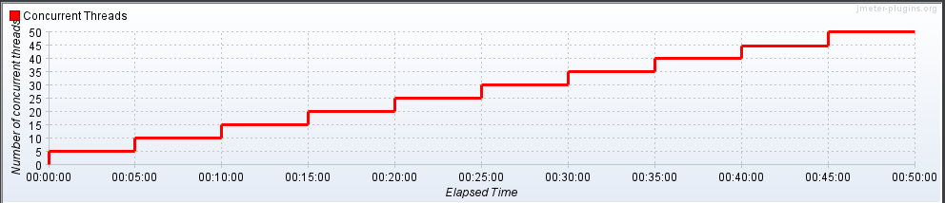

**Analysis**

Based on the provided data, we can derive several key findings:

1. Performance Variation: There is significant variation in response times across different controllers. For instance, the "Login Controller" has an average response time of 32.098 seconds, while the "DecomController" has an average response time of 79.351 seconds. This variation suggests differing performance characteristics across various parts of the application.
2. Error Rates: Several controllers, such as the "SearchPartController" and "QuoteProcessController," exhibit a 100.00% error rate. This indicates that these controllers encountered errors for all or most of the requests during the test. High error rates can significantly impact user experience and require immediate attention to diagnose and rectify underlying issues.
3. Throughput: Throughput values vary across controllers, indicating differences in the application's ability to handle incoming requests. Controllers like the "Login Controller" and "StockController" exhibit relatively higher throughput compared to others, suggesting better performance or optimization in these areas. Higher throughput generally implies better scalability and responsiveness.
4. Data Transfer Rates: The received and sent KB/sec values provide insights into the application's data transfer rates. Controllers like the "DecomController" and "StockController" demonstrate higher data transfer rates, indicating potentially higher resource utilization and impact on network bandwidth. Understanding and optimizing data transfer rates are crucial for efficient resource management.
5. Overall Performance: The total summary data provides an overarching view of the application's performance, encompassing all controllers and sub-requests. It reveals the total number of samples, average response time, error rate, throughput, and other metrics aggregated across the entire test. This holistic perspective allows for an assessment of the application's overall health, identifying areas of strength and areas needing improvement.

In summary, the provided data highlights performance variation across controllers, significant error rates in certain functionalities, variations in throughput and data transfer rates, and an overview of the application's overall performance. Analyzing these key aspects enables a deeper understanding of the application's behavior under load, facilitating targeted optimization efforts to enhance performance, reliability, and scalability.